Title: E-news Application

Step 1: run the index.html using live server, you will get a homepage which displaying the “breaking news” in home page .  
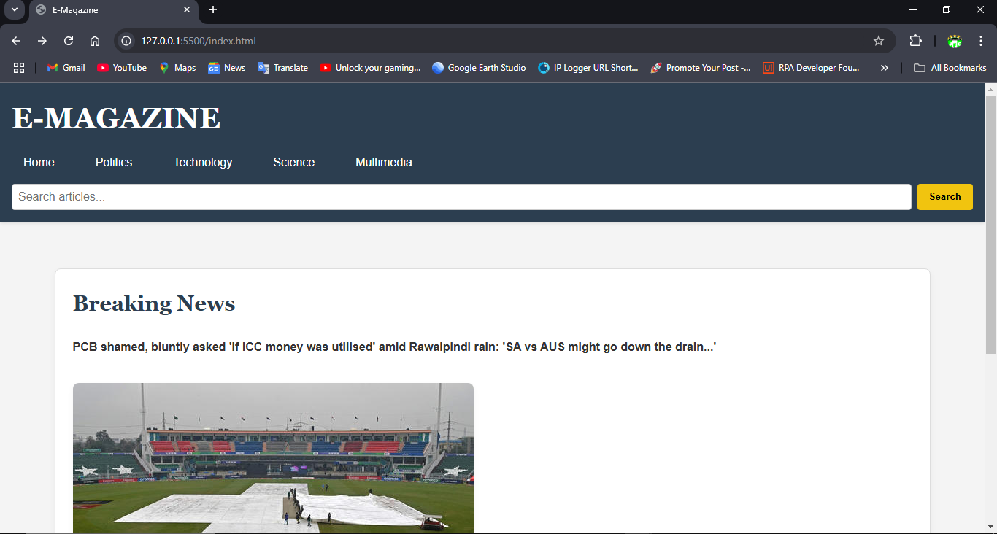

Step 2: To view further news articles on particular search constraint, search the related news and click search button which shows the related articles below the breaking news.Or else to view all the news articles just click the search button without any search input

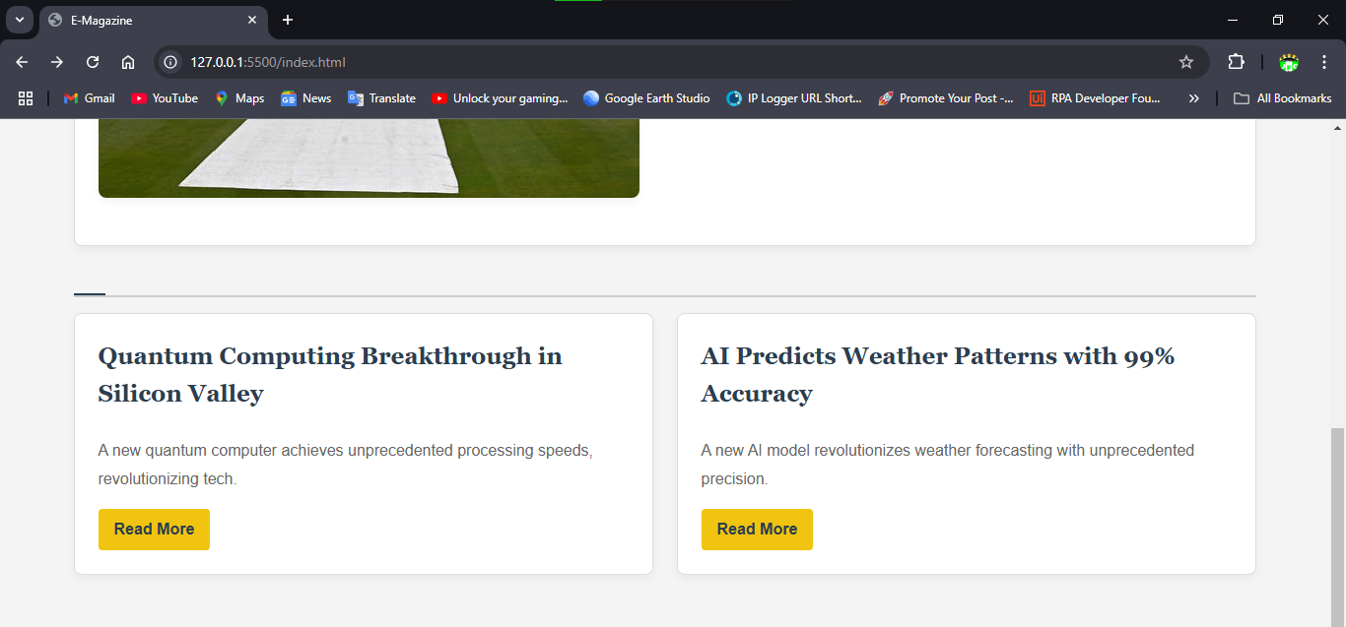For ”tech” search input

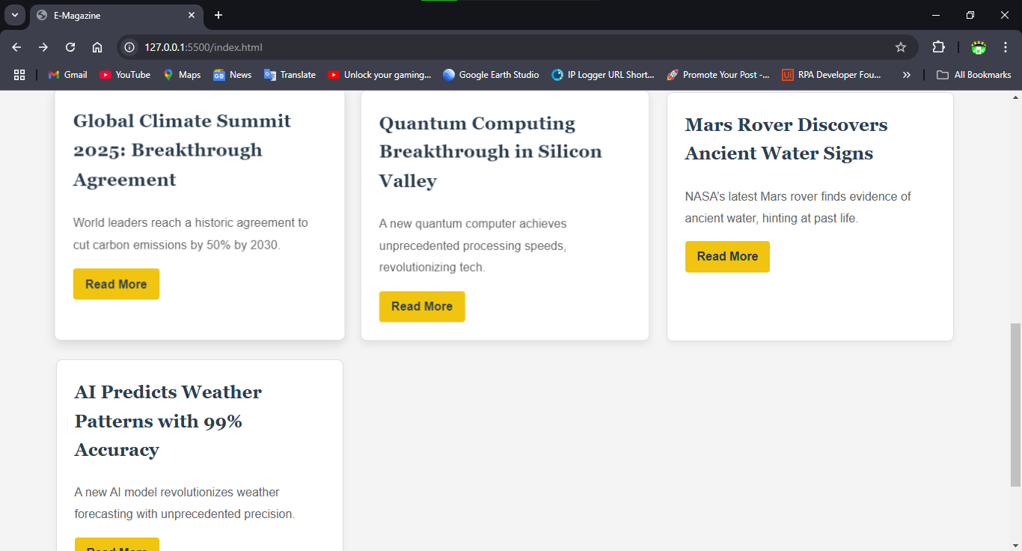Now no input given in search

Step 3: click read more on any articles to view the detailed news description of the particular news and the media attached in respective news article

